

Practices for Secure Software Report

Table of Contents
Document Revision History 3
Client 3
Instructions 3
Developer 4
1. Algorithm Cipher 4
2. Certificate Generation 4
3. Deploy Cipher 4
4. Secure Communications 4
5. Secondary Testing 4
6. Functional Testing 4
7. Summary 4
8. Industry Standard Best Practices 4

Document Revision History

Version | Date | Author | Comments
1.0 | 09/21/2026 | Matthew Delphia | Working draft for Project Two secure software report

Client



Instructions

Submit this completed practices for secure software report. Replace the bracketed text with the relevant information. You must document your process for writing secure communications and refactoring code that complies with software security testing protocols.

- Respond to the steps outlined below and include your findings.
- Respond using your own words. You may also choose to include images or supporting materials. If you include them, make certain to insert them in all the relevant locations in the document.
- Refer to the Project Two Guidelines and Rubric for more detailed instructions about each section of the template.

Developer
Matthew Delphia

Algorithm Cipher

For Artemis Financial, I recommend AES-256 in Galois/Counter Mode (GCM) as the primary encryption cipher. AES is a symmetric block cipher, which means the same secret key is used to encrypt and decrypt data. AES works with 128-bit blocks and supports 128-, 192-, and 256-bit keys. I selected the 256-bit option because it provides a strong security margin for sensitive financial information. GCM is useful because it adds authentication to the encryption process, helping protect both confidentiality and data integrity (NIST, 2023; Dworkin, 2007).

AES does not create a checksum by itself, so I will use SHA-256 for the file-verification portion of the project. SHA-256 is a cryptographic hash function that produces a 256-bit message digest. If the input data changes, the digest should also change, which makes it useful for detecting whether transferred data has been altered (NIST, 2015).

Random values are also important in modern cryptography. Secure random numbers are used when generating keys, nonces, and initialization values so that encrypted data is not predictable. AES is symmetric, while the certificate used for HTTPS uses asymmetric public/private-key cryptography. In a secure web connection, asymmetric cryptography helps establish trust and protect the key exchange, while faster symmetric encryption protects the actual session data.

Encryption standards have changed over time as older algorithms became too weak for modern systems. DES used much smaller keys and was replaced by AES after NIST selected the Rijndael algorithm as the Advanced Encryption Standard. AES remains a current NIST standard, while SHA-256 remains part of the Secure Hash Standard. Using current, standardized algorithms is a better choice than creating a custom encryption method because the algorithms have been widely reviewed and tested.

Certificate Generation
Insert a screenshot below of the CER file.

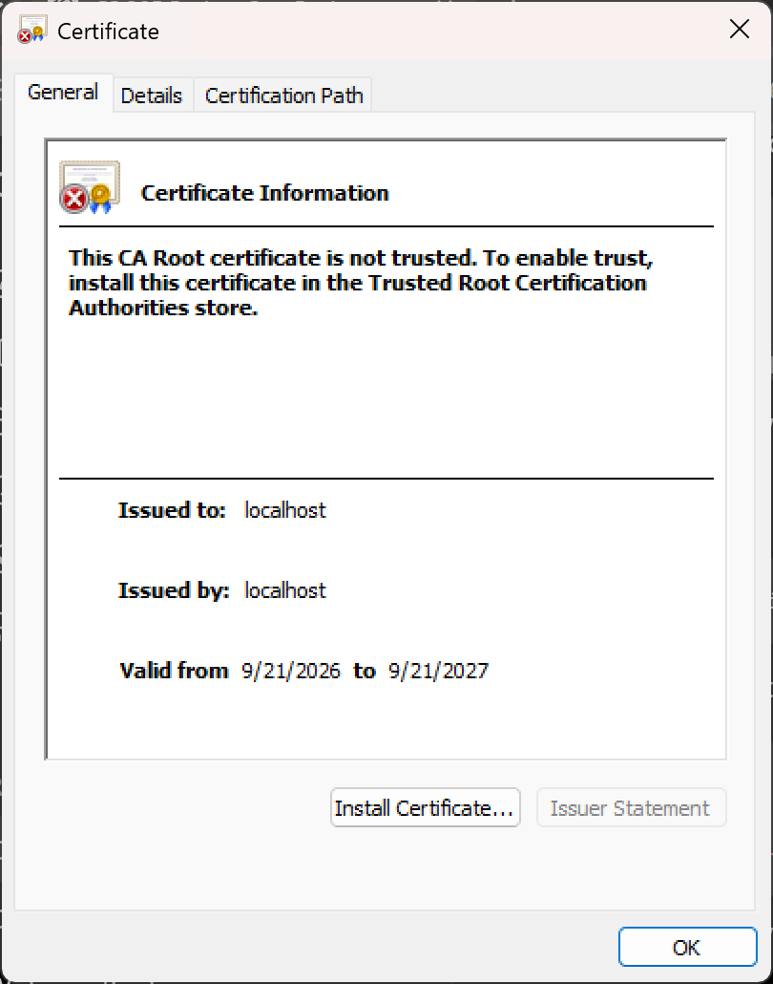

Deploy Cipher
Insert a screenshot below of the checksum verification.

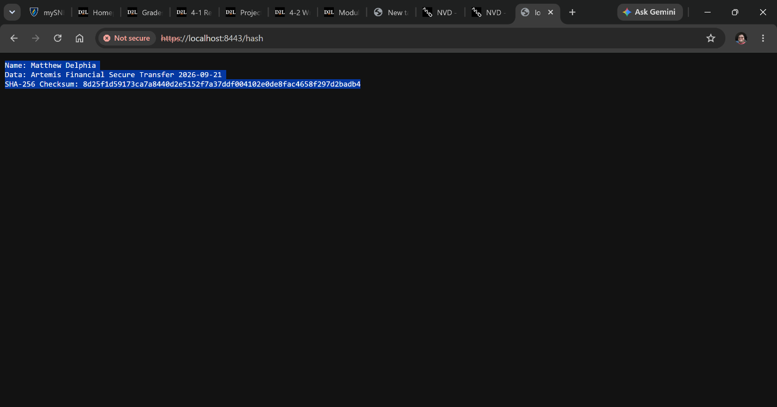

Secure Communications
Insert a screenshot below of the web browser that shows a secure webpage.

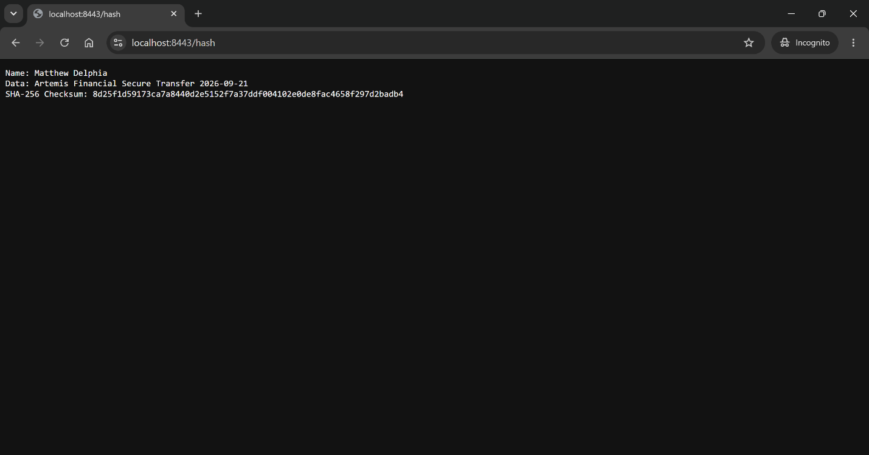

Secondary Testing
Insert screenshots below of the refactored code executed without errors and the dependency-check report.

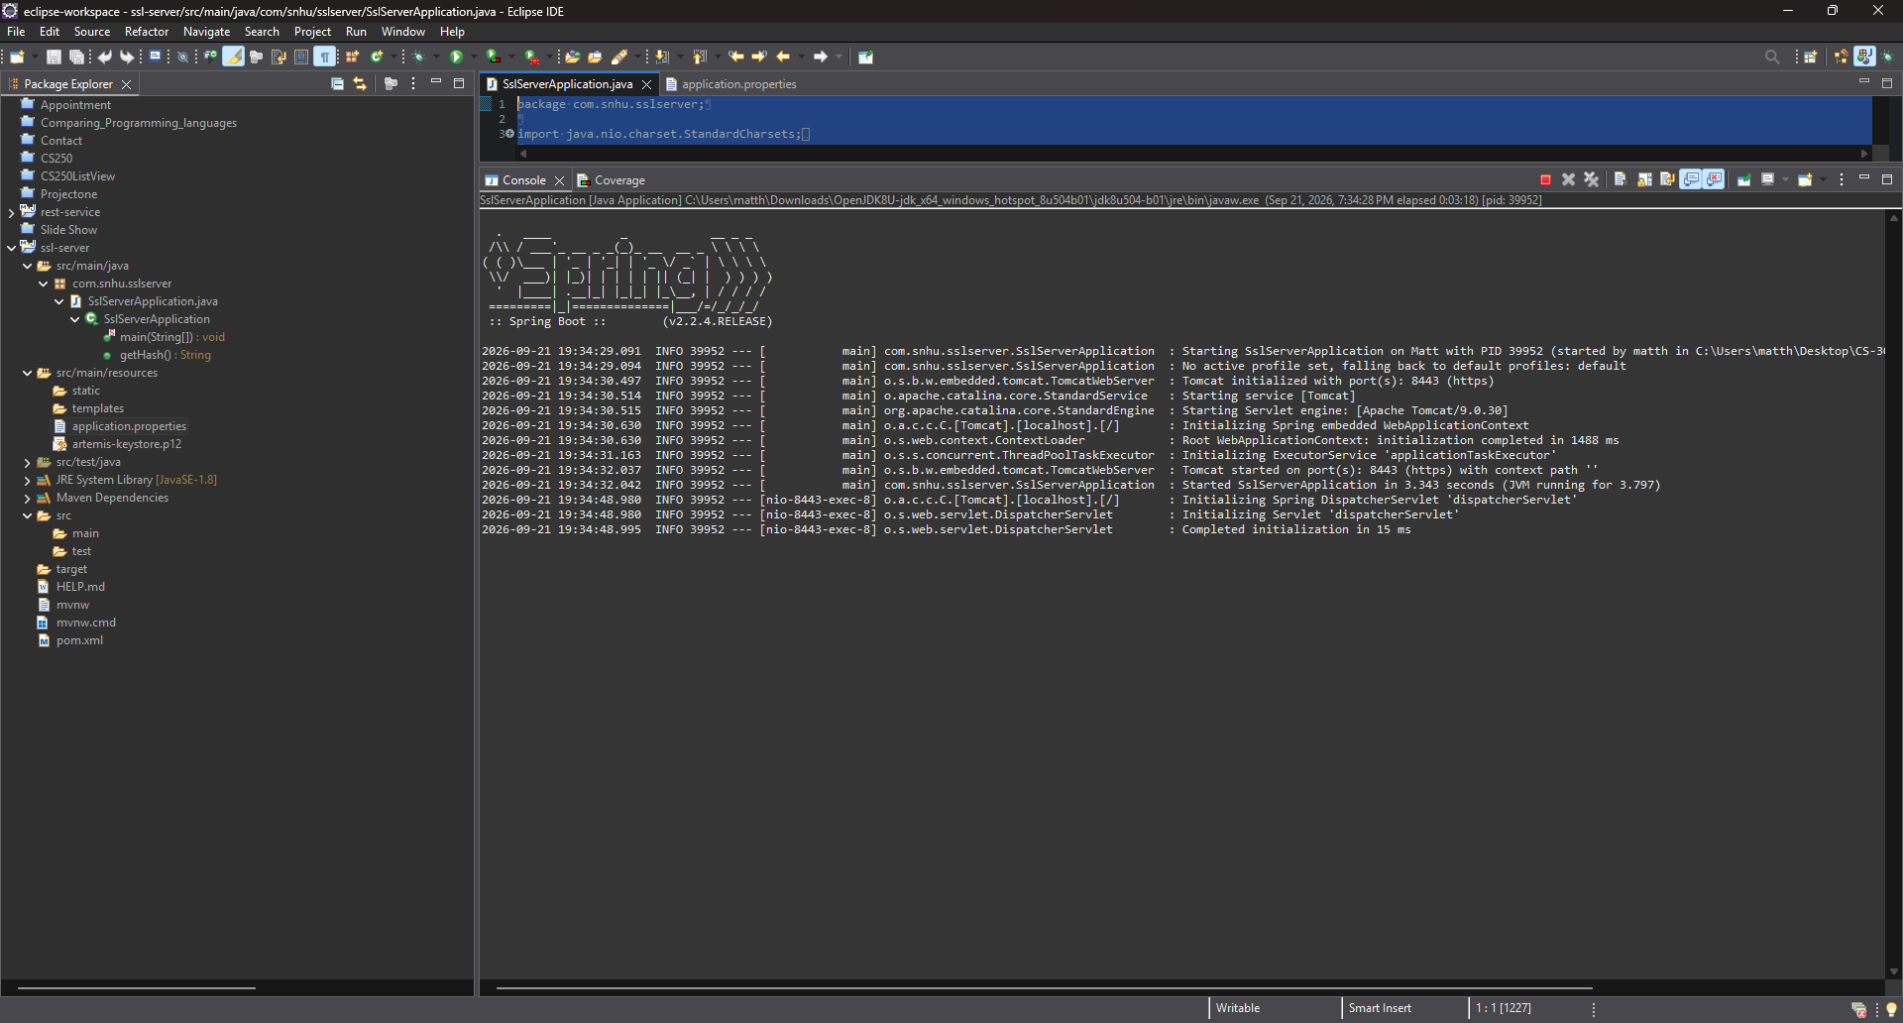

Functional Testing
Insert a screenshot below of the refactored code executed without errors.

Summary
For this project, I refactored the Artemis Financial application to improve data integrity and secure communications. I added SHA-256 hashing to create a checksum for the application data and configured the Spring Boot application to use HTTPS on port 8443 with a PKCS12 keystore and certificate. I also verified that the /hash endpoint displayed my name, a unique data string, and the expected SHA-256 checksum.
After making the changes, I performed security and functional testing. I ran the application to confirm that it started without errors and that Tomcat was using HTTPS. I also tested the /hash endpoint in the browser to verify that the checksum was generated correctly and that the application could communicate securely. In addition, I used OWASP Dependency-Check as part of the secondary testing process to review the project dependencies for known vulnerabilities and to make sure the refactoring did not introduce new dependency-related security issues.
The application now uses multiple layers of security instead of relying on one control. HTTPS protects data while it is being transmitted, the certificate supports secure server communication, and SHA-256 provides a way to verify the integrity of the data. Dependency-Check adds another layer by identifying known vulnerabilities in third-party libraries. Using these protections together helps reduce different types of security risk and provides a stronger overall security process for Artemis Financial.

Industry Standard Best Practices

During this project, I followed several industry standard security practices while refactoring the Artemis Financial application. I used SHA-256 for checksum generation because it provides a strong one-way hash that can be used to verify data integrity. I also configured HTTPS so that information sent between the application and the user is encrypted while it is in transit. The application uses a PKCS12 keystore and a certificate to support the secure HTTPS connection.

I also used OWASP Dependency-Check to scan the project dependencies for known vulnerabilities. This is important because an application can still have security risks even when the code written by the developer is secure. Third-party libraries and frameworks can contain known vulnerabilities, so dependency scanning helps identify areas that may need updates or additional review.

Another important best practice was maintaining the existing functionality of the application while adding security features. After refactoring the code, I tested the application to confirm that it still started correctly, the /hash endpoint worked, HTTPS was enabled, and the checksum was generated as expected. This type of testing helps prevent security improvements from creating new functional problems.

Following secure coding practices is valuable to Artemis Financial because the company handles sensitive financial information. Using encryption, data integrity checks, certificate-based secure communication, dependency scanning, and functional testing can reduce security risks and help protect client information. These practices also make the application easier to maintain and give developers a repeatable process for checking security as the software changes over time.

